**Docker With Django Tutorial**

What is docker?

-- Docker is an open platform for developing, shipping, and running application.

-- In the other words, docker is a platform which packages an application and all its dependencies together in the form of containers.

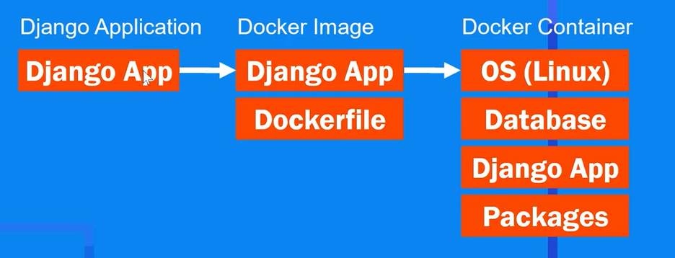

-- Create an empty folder and open it in VS code.

-- Create virtual environment:

> *virtualenv docenv*

-- Activate the virtual env:

> *docenv\Scripts\activate*

-- Install django:

> *pip install django*

-- Create a new django project:

> *django-admin startproject core .*